Footprint notes and questions

$4$-$σ$ code
- The $B_{2}$ matrix can be further simplified:
$$B_{2}=e^{-πi/8}\frac{1}{2}\left[\begin{matrix}1+i & 1-i \\ 1-i & 1+i\end{matrix}\right]=e^{πi/8}\frac{1}{\sqrt{2}}\left[\begin{matrix}1 & -i \\ -i & 1\end{matrix}\right]≅\frac{1}{\sqrt{2}}\left(I-iX\right)$$
- 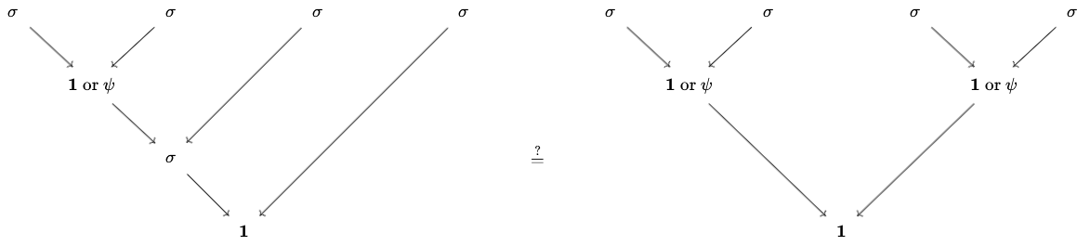
- Formulas used seem to suggest the left basis was used (e.g., the use of $F_{σσσ}^{σ}$ to convert (1,2) basis to (2,3) basis only makes sense for the left side) but only the right picture was shown. Is this intentional to demonstrate that measurement of one fusion gives information of the other?
  - In particular, the use of
  - To convert the LHS to RHS (or vice versa), we need $F_{1σσ}^{σ}$ and $F_{ψσσ}^{σ}$, which I am not sure can be fixed to be the identity.

$6$-$σ$ code
- What is the analogue of Ising Majorana code for Fibonacci anyons?

